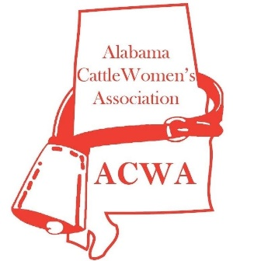
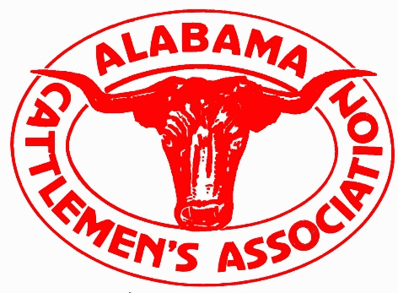
St. Clair County
Cattlemen and Cattlewomen
2021 Scholarship
OFFICIAL APPLICATION

The St. Clair County Cattlemen’s and Cattlewomen’s Associations are honored to each present a college Scholarship of at least $1,000.00 to high school seniors and $500.00 to college students looking to make a positive impact in his or her career field.

REQUIREMENTS AND PROCEDURES:

- Complete the attached application.
- Write a brief essay about the impact you wish to make in your future career field. If possible, explain how agriculture has affected or inspired any part of your life.
- In your essay, DO NOT specify who you are in any form or fashion. Your name should ONLY be written on your application.
- On your application page, please specify the name(s) of any relatives who are current members of the Cattlemen’s and/or Cattlewomen’s Association.
- OR
- If going directly into an agricultural field of study, you may become a member yourself online at www.bamabeef.org (include proof of membership with your application).
- All applications must be postmarked no later than Friday, April 16, 2021. No late applications or essays will be accepted.
- No letters of recommendation, grades or test scores or any other documents are necessary. Please only submit an essay with your application.
- Mail one (1) completed application and four (4) copies of your essay (without staples) to:

St. Clair Cattlemen and Cattlewomen
4619 Old Coal City Road
Ragland, Alabama 35131
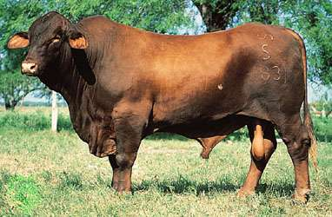
St. Clair County
Cattlemen and Cattlewomen
2021 Scholarship
OFFICIAL FORM

Applicant Name: ______________________________________ Age: _________

Address: ___________________________________________________________

City/State/Zip: ______________________________________________________

Telephone: ___________________ Email: ________________________________

High School Attending: _______________________________________________

Counselor’s Name: __________________ Phone: __________________________

List any relatives in the Cattlemen’s or Cattlewomen’s Association (use back if needed):

Name: ___________________________________ Years Active: _____________

Name: ___________________________________ Years Active: _____________

____ Check here if you are a member of the Cattlemen’s, Cattlewomen’s or Jr. Cattlemen’s Association

College you plan to attend: ____________________________________________

Intended Major or Field of Study: _______________________________________

**In a brief essay, tell us about the impact you wish to make in your future career field. If possible, explain how agriculture has affected or inspired any part of your life. In your essay, DO NOT specify who you are in any form or fashion, or your essay will be voided. Your name should ONLY be written on your application form.

IMPORTANT: ALL APPLICATIONS AND ESSAYS MUST BE POSTMARKED NO LATER THAN FRIDAY, APRIL 16, 2021 OR THEY WILL NOT BE ACCEPTED.

