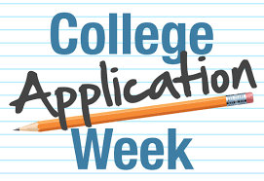
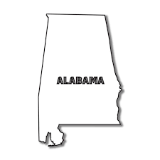
Monday, October 30 – Friday, November 3
Alabama A&M University Springhill College
Alabama State University Stillman College
Auburn University at Montgomery Talladega College
Concordia College The University of Montevallo
Fortis College *** The University of North Alabama
Jacksonville State University The University of West Alabama
Judson College Troy University

Marion Military Institute Tuskegee University
Miles College
Selma University

Out of State Colleges

Alcorn State University – Mississippi
Benedict College – South Carolina
Berea College – Kentucky
Bethune-Cookman College – Florida ***
Claflin University – South Carolina
Dillard University – Louisiana
Edward Waters College – Florida
Fisk University – Tennessee
Georgia College – Georgia
Hampton University – Virginia
Mississippi Valley State – Mississippi
Murray State University – Kentucky ***
Norfolk State University – Virginia
The University of Tennessee – Tennessee
University of Dayton – Ohio
Western Kentucky University – Kentucky
Xavier University of Louisiana – Louisiana

*** - conditions apply

