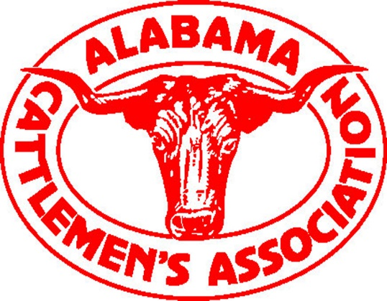
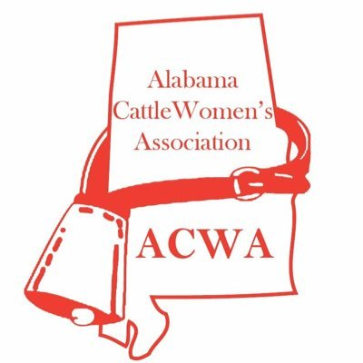

St. Clair County Cattlemen and Cattlewomen
2018 Scholarship
OFFICIAL APPLICATION
The St. Clair County Cattlemen’s and Cattlewomen’s Associations are honored to each present a college scholarship of at least $1,000 to high school seniors and $500 to college students looking to make a positive impact in his or her career field.

REQUIREMENTS AND PROCEDURES:
- Complete the attached application.
- Write a brief essay about the impact you wish to make in your future career field. If possible, explain how agriculture has affected or inspired any part of your life.
- In your essay, DO NOT specify who you are in any form or fashion. Your name should ONLY be written on your application.
- On your application page, please specify the name(s) of any relatives who are current members of the Cattlemen’s and/or Cattlewomen’s Association.
- OR
- If going directly into an agricultural field of study, you may become a member yourself online at www.bamabeef.org. (Include proof of membership with your application.)
- All applications must be postmarked no later than Saturday, March 31, 2018. No late applications or essays will be accepted.
- No letters of recommendation, grades, or test scores, any other documents are necessary; please only submit an essay with your application.
- Mail 1 completed application and 4 copies of your essay (without staples) to:
St. Clair County Cattlemen and Cattlewomen
45 Pepper Road
Cropwell, AL 35054

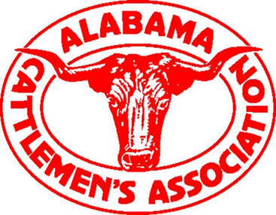

St. Clair County Cattlemen and Cattlewomen
2018 Scholarship
OFFICIAL APPLICATION

Applicant name: ___________________________________________________ Age: _______________
Address: _____________________________________________________________________________
City/State/Zip: ________________________________________________________________________
Telephone: _____________________________ Email: ________________________________________
High School You Attend: ________________________________________________________________
Counselor’s Name: _____________________________________ Phone Number: __________________
List any relatives in the Cattlemen’s or Cattlewomen’s Association (use the back if needed):
Name: ______________________________________________________ Years Active _____________
Name: ______________________________________________________ Years Active _____________
_______ Check here if you are a member of the Cattlemen’s Association, Cattlewomen’s Association or Jr. Cattlemen Association
College you plan to attend: ______________________________________________________________
Intended Major or Field of Study: _________________________________________________________
** In a brief essay, tell us about the impact you wish to make in your future career field. If possible, explain how agriculture has affected or inspired any part of your life. In your essay, DO NOT specify who you are in any form or fashion, or your essay will be voided. Your name should ONLY be written on your application.
IMPORTANT: ALL APPLICATIONS AND ESSAYS MUST BE POSTMARKED NO LATER THAN SATURDAY, MARCH 31, 2018 OR THEY WILL NOT BE ACCEPTED.

